**Product Name:** (Curriculum.AI) ()

**Goal:** Reduce the total time spent on curriculum planning by at least 50%

**Purpose:** (Capture a share of the market of 4300 universities, with each consisting of an average of 15 university departments to eventually become the leading curriculum management software.)

**Type:** (Smart curriculum-planning collaboration management software)

(Intelligent Curriculum Management Software)

**Main Function:**

1. Use machine learning algorithms to form the first version schedule using the past semester schedule data considering the program requirements (class size, classrooms, timings, faculty), course topic, and any constraints. Additionally program administrators (PAs) can also choose to manually input the course information.
2. Show the schedule directly with high readability, PAs can also check schedules from other departments and can make comparisons easily.
3. Multiple users can make real-time changes to the schedule on the calendar which others can see right away (similar to Google Docs, MURAL etc.)
4. Access to program administrators as well as all other stakeholders like faculty and other staff.
5. Built-in conflict finding function to help find the potential conflicts.
6. In-built messaging to record communication and helps avoid long email chains.

**Positioning:** Intelligent and a real-time scheduling application specific to university curriculum planning along with in-built messaging.

**Platform:** Web Application, Android App, iOS App

**Visual:**

**Mental Model:** When PAs think of planning course schedules, they are thinking of a calendar, from Monday to Sunday. Currently, they use excel to form this kind of visual map (for example look at Fig 1). We shall create a calendar-like application which is initially filled with a schedule generated by a machine learning algorithm. The algorithm takes the following data as inputs - schedule of previous years, current courses to be scheduled, classrooms allocated across departments, any extra constraints imposed by the program administrators, and faculty requests about timings. After this is generated, the program administrators and all other stakeholders will be able to see the schedule and change it on the application in real-time. Clicking on any slot that is reserved for a course will bring up a plethora of options like course information, faculty, course materials required, and there will exist version control for the same (like Google Docs where you can see the revision history). We are viewing the tool as a one-stop shop for everything related to course scheduling - writing the course description, timings, materials, classrooms, conflicts, communication. Only this one application needs to be changed for all of that to reflect, and hence eliminate the need to use a different tool for each of the above mentioned tasks which is the case currently.

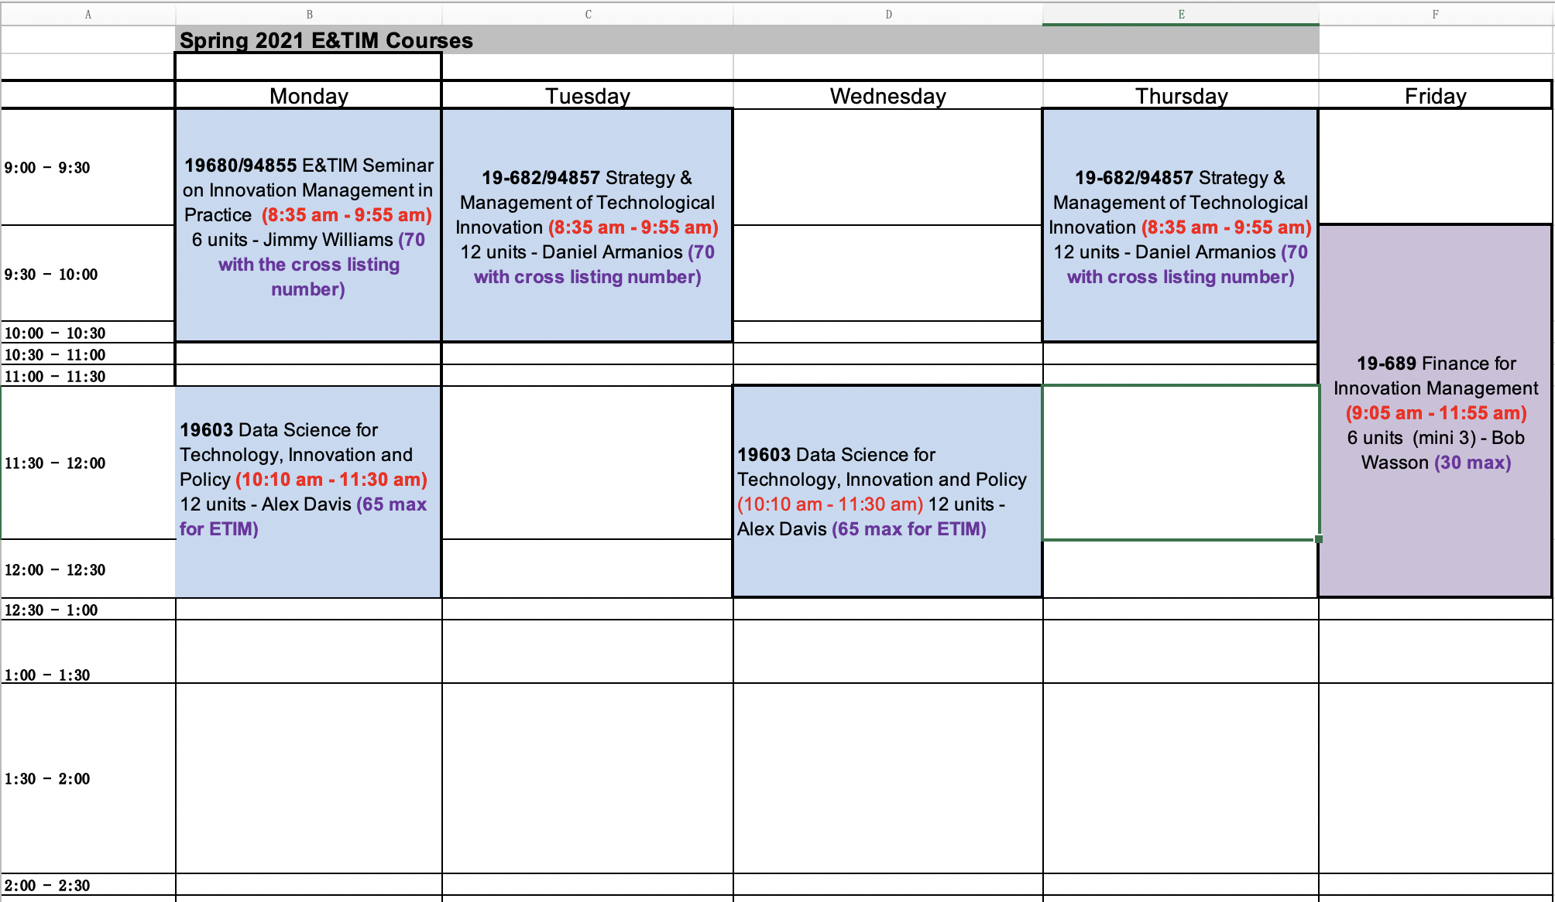

Fig 1 Example of an existing excel tool for course scheduling

Visual of the proposed solution:

